Description-For this assignment, we will be taking a tiered approach to our novel study. Each section of the package contains tiered options for you to choose. You must choose your option prior to beginning each section. You will indicate your selection by completing the tier contract. This must be submitted the day we begin the section. Please see attached agreement at the end of this booklet. The mark beside each tier is the top possible mark you can receive. Note that top marks may not be given just because a student handed-in the assignment. These assignments will be graded for their adherence to the content and syntax requirements as summative or formative.
All packet assignments are due the day of each corresponding group meeting
Part 1-Novel Selection-You will have a selection of four novels. Choose a novel you have not read and consider your individual reading level. Your novel selection will determine your group for the novel group responses we will complete each week. Ms. Lock reserves to right to strongly suggest a novel to you.
Novels for consideration
To Kill a Mockingbird
The Help
Beloved
The Absolutely True Story of a Part-time Indian

Part 2-Vocabulary
Outcome: CR 20.4-Read and demonstrate comprehension and appreciation of grade-appropriate informational (including instructions and procedural texts) and literary (including fiction, nonfiction, script, poetry, and essays) First Nations, Métis, Saskatchewan, Canadian, and international texts. Indicator-d-Demonstrate critical reading behaviours
Tier 1 (15/15 marks)-In order to be considered for the Tier 1 marking, you must complete the following by the due date. Late assignments will automatically be moved to the next Tier as the top possible mark.
- Vocabulary Log-Choose at least 15 words from your novel with which you are unfamiliar. You must provide the word, definition, part of speech and an original sentence in which the word is used in context.
- Create a crossword of your 15 selected words. Provide the puzzle with clues and an answer key
- Tone and Mood-Select 10 different words that reinforce the overall tone and mood of the section. You will need to provide a 1-2 sentence explanation of each word’s contribution to the tone and mood
Tier 2 (12/15 marks)-In order to be considered for the Tier 2 marking you must complete the following by the due date. Late assignments will be move the bottom Tier.
- Vocabulary Log-Choose at least 15 words from your novel with which you are unfamiliar. You must provide the word, definition, part of speech and an original sentence in which the word is used in context.
- Create a crossword of your 15 selected words. Provide the puzzle with clues and an answer key
- Select 6 different words that contribute to the time period of your novel. You must supply a 1-2 sentence explanation why they are appropriate to the time period.
Tier 3 (9/15marks)- In order to be considered for the Tier 2 marking you must complete the following by the due date. Late assignments will be move the bottom Tier.
- Vocabulary Log-Choose at least 15 words from your novel with which you are unfamiliar. You must provide the word, definition, part of speech and an original sentence in which the word is used in context.
- Create a crossword of your 15 selected words. Provide the puzzle with clues and an answer key
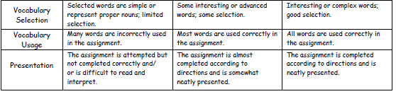

Part 3-Reading Journals-Connect and Respond
Outcome: CC 20.1-Create a range of visual, multimedia, oral, and written texts to explore
Outcome: CC 20.4-Create a variety of written informational (including an essay of explanation of a process, an application letter and résumé, and an argumentative or a persuasive essay) and literary (including a reflective or personal essay and an analysis of a literary text) communications. Indicators-Literary Analysis
Outcome: CR 20.4-Read and demonstrate comprehension and appreciation of grade-appropriate informational (including instructions and procedural texts) and literary (including fiction, nonfiction, script, poetry, and essays) First Nations, Métis, Saskatchewan, Canadian, and international texts. Indicator-f. Read and demonstrate an understanding of the main ideas, events, or themes of a variety of increasingly complex literary and informational First Nations, Métis, Saskatchewan, Canadian, and international texts (including stories, novels, essays, scripts, poetry, research, procedures, websites, blogs, email, message boards); identify and assess the author’s purpose, ideas, point of view, tone, techniques, and overall theme or message.

For these tiers you will be required to select questions from your tier only and complete 3 responses.
Tier One Questions-(30 marks)- Each reading response must be two pages, double-spaced typed (Times New Roman, size 12 font) per entry. Reponses should address the questions, but be completed in paragraph format.
- How does the author use any two of the following? Humour, Irony, Symbolism, Allegory or Metaphor
- Identify two motifs from your novel and explain how they contribute to one of the themes.
- What is the major conflict at this point in your novel? What type of conflict is being used? Who or what does the conflict involve? How does the conflict contribute to the overall theme?
- How does the author create the tone and mood of this novel? Choose at least two different methods that are being used to contribute to the tone and mood.
Tier Two Questions-(22/30 marks)- Each reading response must be one-one and a half pages, double-spaced typed (Times New Roman, size 12 font) per entry. Reponses should address the questions, but be completed in paragraph format.
- Does the time and location of the novel change during the book? Explain how and give direct examples. How do these changes contribute to the plot of the novel?
- Compare and contrast two characters psychologically. To do this, consider their behavior and personality. Consider whether their physical descriptions match or differ with their behaviour & attitudes
- Who is the narrator of the story? Are they inside the plot or an outside observer? What is their relationship to the overall plot?
- Choose one sentence or phrase that intrigues you. Explain why you chose it, its value to the theme and plot of the book and its use and purpose.
Tier Three Questions-(18/30 marks)- Each reading response must be one page, double-spaced typed (Times New Roman, size 12 font) per entry. Reponses should address the questions, but be completed in paragraph format.
- Name and describe a secondary character. Describe them physically and describe their personality and history (if the author has provided this). How are they important to the plot of the novel?
- Find two specific ideas, events, or behaviours in the novel that relates to real life (Text to Self or Text to World)
- Come up with 5 meaningful questions you had while reading this section of the novel. Explain why you came up with these questions in 1-2 sentences
- Describe two text to text connections you made with this section of the novel. Be sure to be detailed in your description of the connection as well as the other text you are relating your novel to.

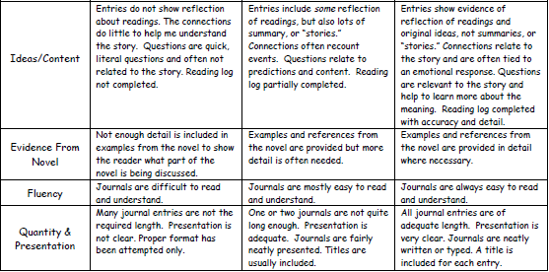

Part 4-Story Element Activities (Visualize, Synopsis, Theme)
Outcome: CC 20.2-Create visual or multimedia presentations using dramatization or role-play, including a presentation of an interview of a literary character (or author or historical or contemporary person) from a First Nations, Métis, Saskatchewan, Canadian, or international text.
Indicators-b- Select, use, and evaluate critically a variety of before (page 23), during (page 24), and after (page 25) strategies to construct and communicate meaning when representing.d- Create and present a visual or multimedia presentation of an interview with a literary character (or author or historical or contemporary person) using dramatization or role-play:e- Present information incorporating visual, audio-visual, and dramatic aids to engage the intended audience and achieve the purpose.

For each tier you will be required a determined amount to select from the sections below. Be sure to read your tier carefully to ensure you are completing the appropriate amount of activities.
Tier One-(25 marks)-Complete 2 character activities, two setting activities and 2 plot activities
Tier Two-(20/25 marks)-Complete 1 character activity, two setting activities and one plot activity
Tier Three-(15/25 marks)-Complete one activity from each of the sections
Section One-Character
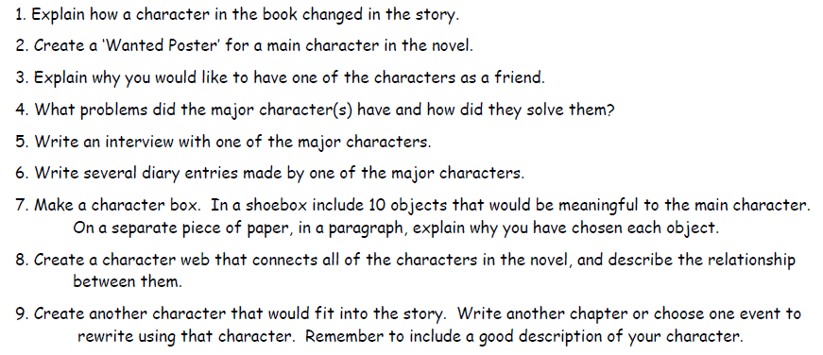
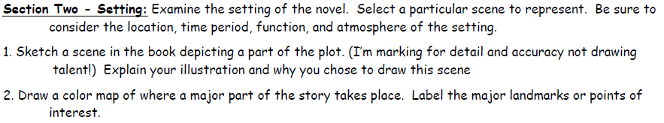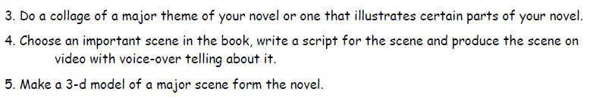
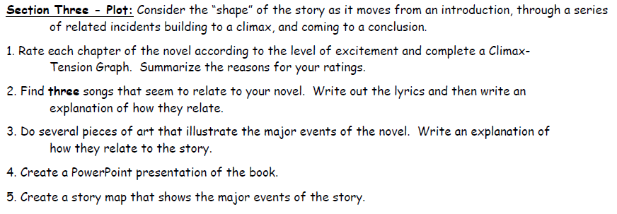

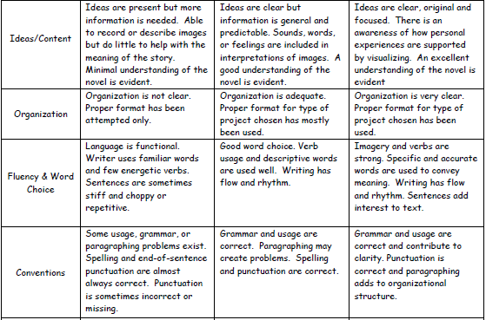

Part Five-Reader Reflection (Infer and Transform)
Outcome: CC 20.4d, f, g-Create a variety of written informational (including an essay of explanation of a process, an application letter and résumé, and an argumentative or a persuasive essay) and literary (including a reflective or personal essay and an analysis of a literary text) communications. Indicators–Reflective Essay, Persuasive Argument, Literary Analysis, Letter of Application and Resume, Personal Essay
When we read between the lines or look for deeper meaning, we are inferring. When that deeper understanding leads to a change in the way we see or do things, we are transformed. Your task is to look for the deeper meaning of the novel you read making specific reference (direct quotations) to the text and defending your position with sound reasons, and to discuss how this understanding changed you. Please read the requirements for each tier carefully.
Tier One-(25 marks)-Choose 3 of the activities below. Include titles or any necessary headings
- Write a five paragraph essay of reflection (personal essay)/personal commentary that expresses a unique view of an aspect of life presented in the novel that is important to the student or supports the writer’s viewpoint of life.
- Write an editorial concerning a factually correct issue presented in the novel that states clearly a position about the current issue or problem, supports your position with reasons, is persuasive, and offers realistic solution, provides support and answers/addresses any objection, closes by restating the position, calling for action, or asking reader to get involved and be sure to choose inclusive and respectful language and qualifiers to strengthen position.
- In two separate paragraphs, analyze the author’s use of two literary elements and how these contribute to the overall theme of your novel. Each paragraph needs to be 11 sentences and use 3 direct proofs from your novel.
- Create a properly, fully developed resume and cover letter for one character in your novel. You need to choose a specific job or career that your character would apply for and consider the era in which your novel’s setting takes place.

Tier Two-(20 marks)-Choose 2 of the activities below. Include titles or any necessary headings.
- Write a book review of the novel wherein you attempt to convince someone else to read the novel. Be sure to use persuasive and descriptive language to engage the reader.
- Write a letter to the author of the novel expressing your thoughts on the novel, questions that you have about the context and inspiration for the novel, questions about the author’s history, background etc.

Tier Three-(15 marks)-Choose 1 of the activities below. Include titles or any necessary headings.
- Create a brochure to promote the book. Include a review of the novel in 1-2 complete 8-11 sentence paragraphs wherein you try to get someone else to read it. Include a novel summary and pictures.
- Imagine the book you read just became a movie. Write a newspaper review to discuss the characters, plot or just general theme. Be sure to identify what actors or actresses would play the characters in the movie.
- Create a comic strip that has at least 12 frames (including a title frame) in which you present an issue addressed in the novel and a solution to that issue. You do not have to use the characters from the novel. You will need to create your own characters and plot to address the issue.
- Choose one character and create a properly formatted resume and cover letter for a job that is appropriate to the era in which the novel takes place.
- Choose one character and create a full description of that character considering physical, personality traits and motivation. Minimum 11 sentences and a fully developed topic sentence to introduce your paragraph.

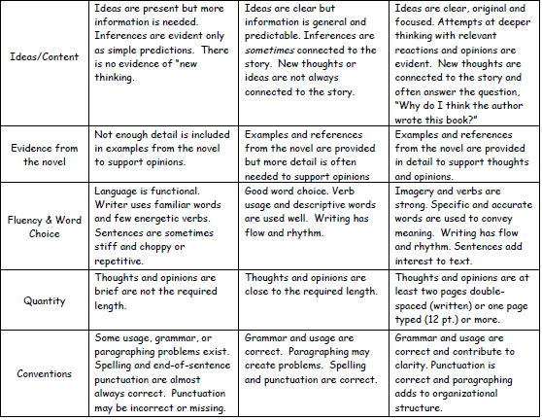

Group Responses-(20 marks)-Once a week we will work in groups to respond to a question that is found on my website under ELA 20 Blog Page. There is no tiered marking for this assessment.
Outcome: CC 20.3-Speak to present ideas and information appropriately in informal (including discussions and collaborative work) and formal (including an interview, a dramatic reading, and introducing and thanking a speaker) situations. Demonstrate flexibility in assuming a variety of group roles and take responsibility for tasks that achieve group goals
Outcome: AR 20.1-Assess own ability to view, listen, read, speak, write, and use other forms of representing effectively.

These responses will be completed in groups of 2-4 people. These groups can change every week, but the groups members must be reading the same piece of literature.
Group Meeting #1-Monday, February 11th-Groups will meet with members that have the same novel to section the novel into 4 parts
Group Meeting #2-Monday, February 25th-Groups of 2-4 will meet to answer Section #1 of on the Novel Blog Page
Group Meeting #3-Wednesday, March 6th-Groups of 2-4 will meet to answer Section #2 on the Novel Blog Page
Group Meeting #4-Friday, March 15th-Groups of 2-4 will meet to answer Section #3 on the Novel Blog Page
Group Meeting #5-Monday, March 25th-Groups of 2-4 will meet to answer Section #4 on the Novel Blog Page.

Tiered Assignment Contract-Section One
I, _____________________________________, will be choosing to complete Tier _____ for this section of my novel.
Student signature________________________________________

Tiered Assignment Contract-Section Two
I, _____________________________________, will be choosing to complete Tier _____ for this section of my novel.
Student signature________________________________________

Tiered Assignment Contract-Section Three
I, _____________________________________, will be choosing to complete Tier _____ for this section of my novel.
Student signature________________________________________

Tiered Assignment Contract-Section Four
I, _____________________________________, will be choosing to complete Tier _____ for this section of my novel.
Student signature________________________________________

