SPARTANS TEAM HANDBALL

Manual

- The Playing Area
- Duration of Play
- The Ball
- The Players
-Eligibility of Participants
-Substitution
- The Goalkeeper
- The Goal Area
- Playing the Ball
- The Approach to the opponent
- Scoring
- Throw-off
- Throw-In
- Goal Throw
- Free Throw
- Penalty Shot
- What do you need as a referee
- Referee signals
- Referee Positioning
- Skills and Practices

The Playing Area
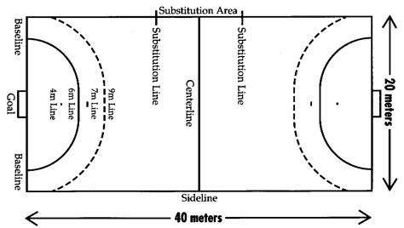

- Substitution line is 4.5metre from Center line on each side
Handball Goal is 3meters in width by 2 meters height

Duration of Play
Official IHF Time of play
- Sr and- U-21 2x30min halves with 10 min Half Time
- U-18- 2x20min halves with 10 min half time
- U-16- 2x15min halves with 5 min halftime
- U-14,U-12- 2x15min halves with 5 min halftime

Regina Youth League Handball time of play
- Sr and U-21 League 2x25min with 5 min Half time
- Regina Youth Leagues and Provincials 2x22 minutes with 5 min halftime

Start of the Game

- The Referee’s will call the team representatives and the winner of the coin toss shall have the option of having the ball in what half or what side to take.

- The game starts with the court referee’s whistle for the throw-off at center court. The team change ends for the 2nd half of play and the throw off is taken by the other team at center court.

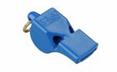

The Players

- A Team Consists of 14 players, you can up to 16 players on a roster but 14 on a game sheet
- A Maximum of 7 players are allowed on the court at any one time. The remaining players are substitutions.

At Start of the Game

Both teams must have at least 5 players on the court.
(4 court players and 1 goal keeper)

- All Court players must be dressed the same and the goalkeeper must wear colours which distinguish them from the court players.
- All Players must have numbers on Jerseys and shall be contrasting colors then the Jersey and measure at least 20cm high on the back and at least 10cm high on front left chest.

Eligibility of participants
- A Player is eligible to play if he or she is included on the score sheet and present at the start of the game.
- An eligible player may be substituted into the game, any number of times during that game, provided that both players enter and exit the court at the times substitution area. It is important that the players being substituted leave the court before the new player enters the game.
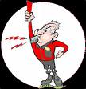

Substitutions

General Substitutions

- All Players shall leave or enter the court only from their own team’s substitution line
- Substitutes may enter the game anytime (with-out notifying the table’s officials) providing that the players they are replacing have already left the playing area.
- During time-outs the substations may only be happen with the referee’s permission

Any player who enters or leaves the court incorrectly shall be punished for an illegal substitution.

Illegal substations are penalized be a free throw. The throw is taken from the sideline at center court. The entering player will be penalized with a 2 minute penalty.

Extra players on the court:
The extra player will receive a 2 min penalty and another player on the court must leave the court for the 2min penalty

If a Suspended player enters the court:
The player will be suspended for additional 2 minute period and another player must leave the court for the players remaining 2 min

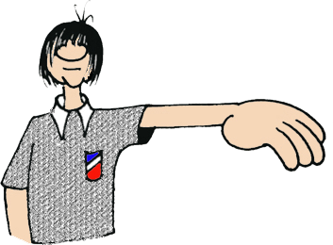

The Goalkeeper

A Goalkeeper can never replace a court player.
(However, a court player may replace a goalkeeper providing that the court players change uniforms before substitutions and does not change their number)

The Goalkeeper is permitted to:

- Touch the ball with any part of their body in their own goal are.
- Move around with the ball inside the goal area without any restriction
- Leave the goal area without being in possession of the ball and participate in the game in the playing area, subject to the rules applied to court players.
- Hold the ball for 5 seconds in the goal area

The Goalkeeper is not permitted to:

- Leave the goal area with the ball under control
- Touch the ball while it is stationary or rolling on the ground outside the goal area while the goalkeeper is inside the goal line
- Re-enter the goal area from the playing area while still in possession of the ball

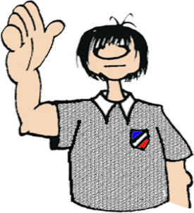
The Goal Area

- Only the goalkeeper is allowed to enter the goal area. The goal area (including the goal Line) is regarded as entered when a court player touches it with any body part.

When a court player enters the goal area:

- Free Throw: (Attacking Player) if the court player enters the goal area while in possession of the ball or if the player enters the goal area with-out possession of the ball and thereby gains advantage.
- Penalty Shot: (defending player) if a defending player enters the goal area and gains advantage over an attacking opponent who is in possession of the ball

However, a court player who enters the goal area:

- After playing the ball which does not result in a disadvantage to the opponent
- With-out the ball and gains no advantage
- During or after an attempt to defend without resulting in a disadvantage for the opponent
SHALL NO BE PENALIZED!
If a player intentionally plays the ball into their own goal area:
It results in a:

- Goal: if the ball completely enters the net
- Free throw: if the goalkeeper touches the ball and it does not go into the net.

Playing the Ball

A Player is permitted:

- To throw, catch, stop, bounce, push or hit the ball in any manner and in any direction by using hands (open or closed), arms, head, torso, thighs.
- To hold the ball for a maximum of 3 seconds, even when it is lying on the ground.
- To take a maximum of 3 steps with the ball
- To bounce the ball once and catch it again with one or both hands, while running or standing, and to bounce the ball repeatedly with one hand (i.e. dribble the ball) while running or standing.
- To move the ball from one hand into the other hand
- To play the ball while kneeling, sitting or laying on the ground

As soon as the ball is held for in one or both hands, it must be played within 3 seconds or after a maximum of 3 steps.

- infraction is considered passive play and penalized be a free throw from the spot where the ball was when play was interrupted )

Note: play continues if the ball touches a referee on the playing field

The Approach to the Opponent

A player is permitted to:

- To make use of one’s hands are arm to gain possession of the ball or to use an open hand to play the ball from an opponent.

A player is not permitted to:

- To obstruct an opponent with arms, hands or legs
- To push an opponent into the goal area
- To pull or hit the ball with one or both hands out of the opponents hands
- To endanger an opponent with the ball or to move the ball towards the opponent in a dangerous feint
- to hold or push an opponent with one or both hands
- to run into, to jump into, to trip up, to hit or to threaten an opponent in any other way
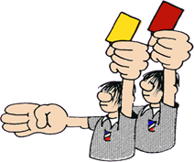

Scoring

Goal
- A goal is scored when the whole of the ball has crossed the inner goal line
No Goal
- If the referee or the timekeeper has blown the whistle before the whole of the ball has crossed the inner line,

When a defending player commits an infringement of the rules in an attempt to prevent he scoring but the ball still goes into the goal, the goal shall be awarded

If a defender scores on their own goal, the goal shall be awarded for the opponents.

If the referees have allowed a goal and have blown the whistle for the subsequent throw off, the goal cannot be disallowed any longer.

Throw Off

The throw-off is used to start the game/second half and resume play after a goal has been scored.
- It is taken at center court
- May proceed in any direction
- Must occur within 3 seconds after the referee’s whistle

All players must be on their own half of the court and opponents must be at least 3 meters from taking the throw-off.

Throw-in

Awarded..... If the whole ball crosses the sideline, or if a court players of the defending team last touched the ball before it crossed the outer line.

- It is taken with-out a whistle signal from the referee be a player of the team opposite to that of the last player to touch the ball
- It is taken from the place where the ball crossed the line or from the end of the side line on the side of the goal where the ball crossed the outer line.
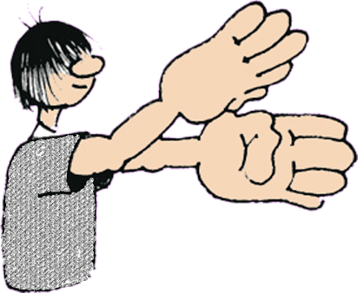
- The player taking the throw in must have one foot on the side line until the ball left their hands
- Opponents must remain a minimum of 3 meters from the thrower

Goal Throw

Awarded..... When the ball crosses the outer goal line

- It is taken from the goal area (over the goal area line) with-out a whistle signal from the referee
- If the ball comes back to rest in the gaol area, the goalkeeper shall bring the ball back into play
- The goalkeeper must not touch the ball after goal-throw until it has touched another player.
Free Throw

Awarded..... For infringement of the rules.

- It is taken without a whistle signal from the referee from the place where the infringement occurred

(Note: if a free throw is awarded to the attacking team and the infringement occurred between the goal area line and the free throw line of the defending team, the free throw shall be taken from the nearest point outside the 9 meter line.)

- If an attacking player is prepared to throw, the player may not put the ball down and pick it up again (dribble)
- Players of the attacking team must not cross their opponent’s free throw line while the throw is taken. Referees must correct the positions of any attacking players inside the free throw line. The free throw shall then be taken following the referee’s whistle signal.

- The opponents must remain at least 3 meters away from the attacking player when the free throw is taken.

Penalty Shot
- A clear chance of scoring is spoilt by an infringement in any part of the court (even when committed by an official)
- A court player enters their goal area to gain an advantage over an attacking player in possession of the ball.

- It is to be taken as a shot towards the goal within 3 seconds after the referee’s whistle
- The player taking the penalty shot may not touch or cross the penalty line (7meters) before the ball left their hands
- Once the throw has been taken the ball may not be touched until it has touched the goalkeeper or the goal
- No player, with the exception of the player taking the penalty shot, may be between the goal area line and the 9 meters when the throw is being taken

Defending team’s position:
- These players must stand 3 meters from the thrower

Goalkeeper’s position
- If a goalkeeper touches or crosses the goalkeeper’s line (4 meters line) before the ball has left the throwers hand, the penalty shot shall be re-taken if a goal was not scored.

Advantage Rule
- When a clear chance of scoring is denied to the extent that a goal is not scored, a penalty Shot must be awarded

Referee Signals

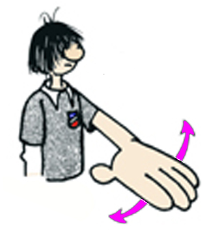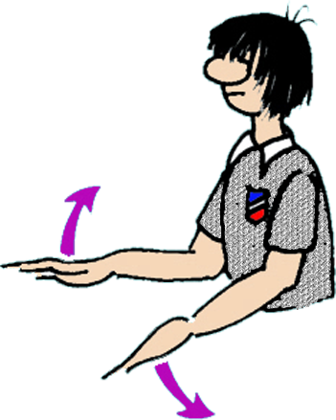
Line Call Double Dribble

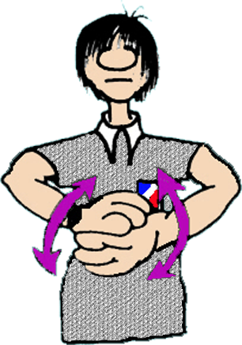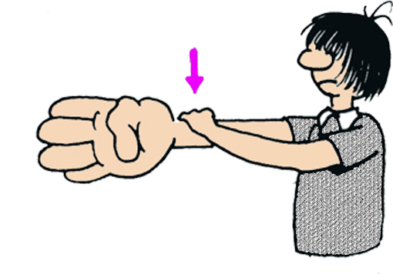
Travel or 3 Seconds Hitting the Arm

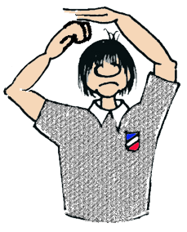
Charge Free Throw

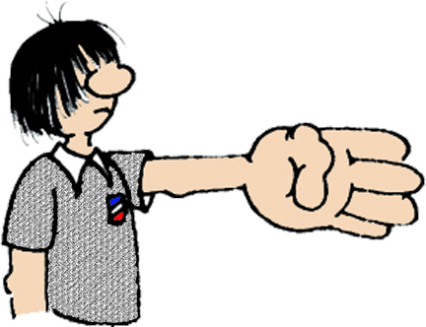
Goalie’s Ball Free Throw Direction

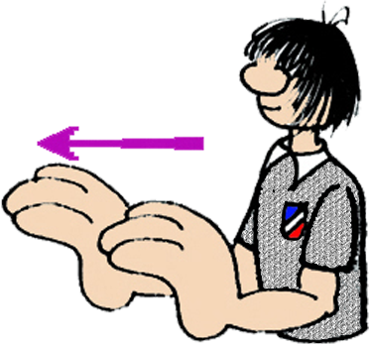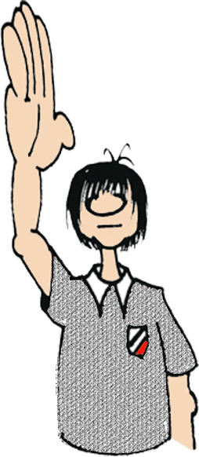
Push back give 3 meters Goal 2 whistles

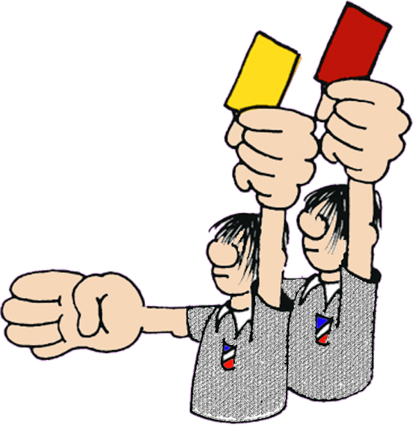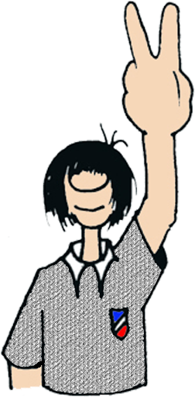
Yellow or Red Card 2 min penalty

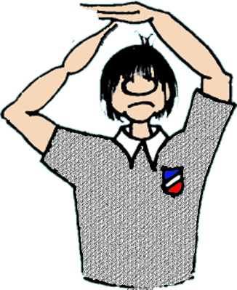
+
Whistle
Whistle
Whistle

Time Out

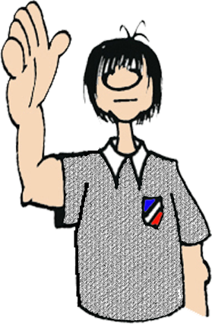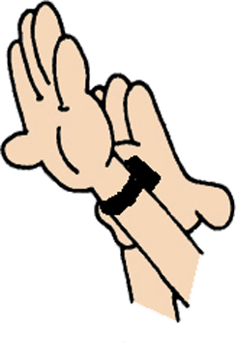
Passive play Warning Passive called
Arm 90 degrees

