Plot Development in “March 2010”

- Read “March 2010” by Denis Farr.
- This story is a “choose your own adventure” style where you can decide the outcome.

Before Reading:

In your opinion, how is the ability to choose how this story progresses and ends like playing a video game? Explain your answer giving an example from a video game.

During Reading:

Jot down the page options you chose as you were reading. List the order you chose below.
Example: page 2, page 6, page 2, page 4, page 3, page 5

After Reading:

Based on your reading listed on the previous page, fill out the plot structure diagram to show how the story started, progressed, and ended.

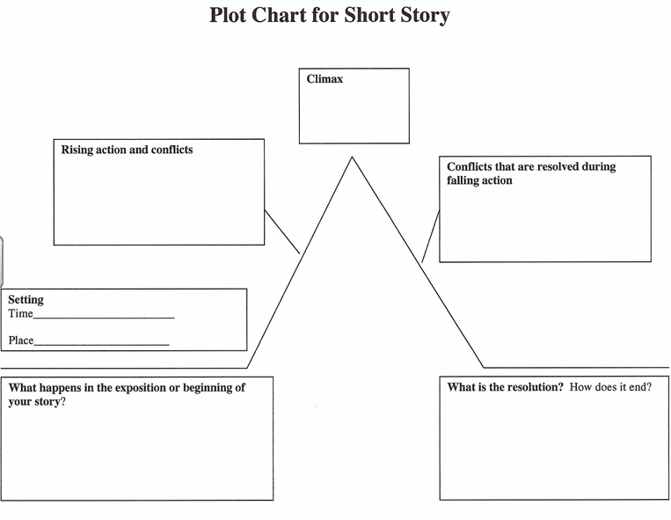

Did you like the way the story ended, or did you go back to read it again in a different way? Explain your answer below with support from the story:

In your opinion, is this video game story a “safe” option for children? Is there a difference between reading about a violent video game and actually playing a violent video game? Explain your answer below with support from the story.

