SOCIAL EXPERIENCE
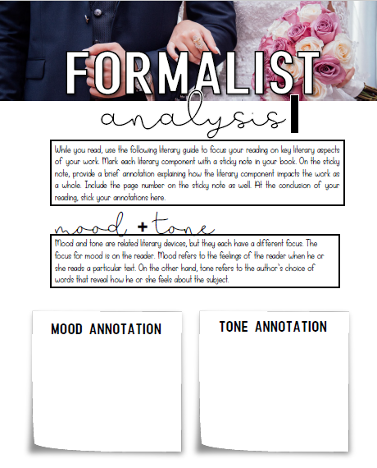
Section #1
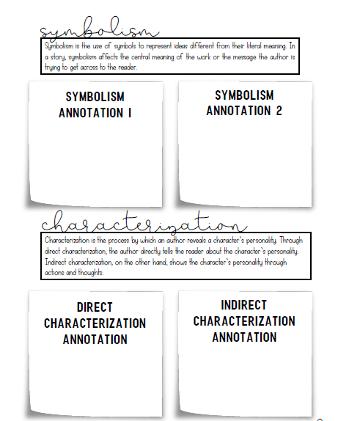
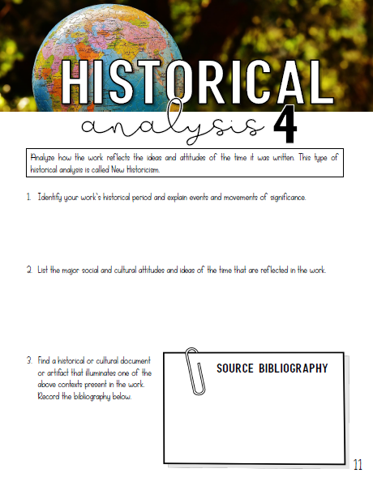
Section #2

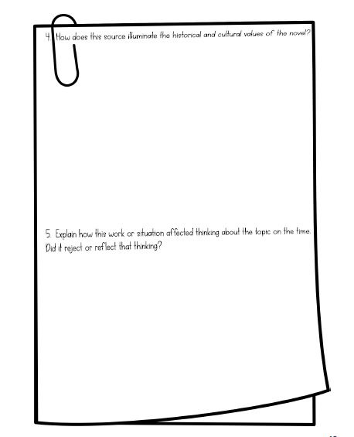
6. To what extent is the historical context important to the reader’s understanding of the novel? Explain using direct references from Section #2 of your reading.
5.
The novels in this unit all address debatable issues. Identify 2 in your novel and state whether you believe the author is giving an unbiased view of the issues. Why or why not?
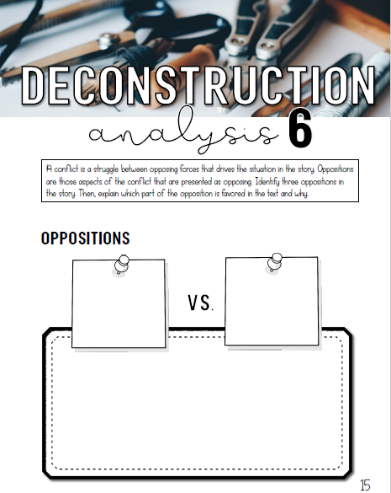
Section #3

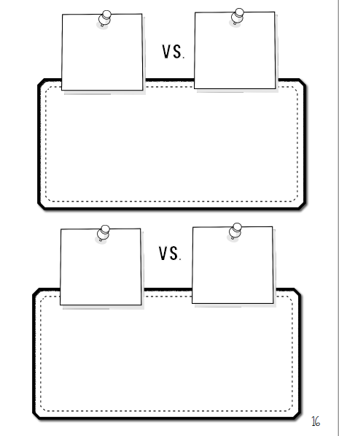

Deconstruction looks at what makes a text whole and what holes are in between its pieces; in other words, what's said and what's left unsaid.
2. What ultimate or definitive meanings do you believe are lost in the text? Keep in mind the definition of Deconstructivism found at the bottom of this page.
- How are implicit ideological values revealed in the work? Give 5 specific examples from Section #3 of your reading. Be sure to include page number.

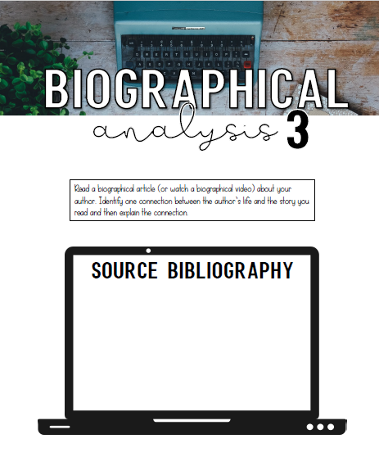
Section #4

2. Does the writer challenge or reflect the values of her contemporaries? Explain using evidence from your reading of any of the sections. Be sure to document your evidence.
- Are characters and incidents in the work versions of the writer's own experiences? Are they treated factually or imaginatively?

Socratic Seminar “Roulette”
Outcomes
CCB30.2a Prepare and present visual and multimedia presentations, c. apply accurately and effectively the language cues and conventions to construct and communicate meaning when representing,
CCB30.3d. Create and present oral presentations, e. Plan and lead a workshop/seminar presentation

During this unit on Khaled Hosseini’s A Thousand Splendid Suns, The Kiterunner and And the Mountains Echoed, our seminars will work a little differently. At the start of this novel study, you’ll be presenting some research on Afghan culture for the class in groups, as well as generating discussion topics and a short fact sheet along with a Works Cited Page that you will need to legitimize your research.

Because Afghanistan and Afghan history are such complex, fascinating subjects, we’ll be relying on you to provide the class with crucial context on the nation’s culture, history, society, economics, and gender roles. You’ll complete a few different tasks:

- Every group will choose 4 of the following topics to present to the class. You will need to use a short visual support for your presentation. This will need to include photos and short text in your visual. This portion can be completed in any format your group would like (poster, powerpoint, prezi etc)
- Each group will create one page of information for each topic that can be used as a hand out for the class. This information must be in your own words and cited properly.
- On the day of your groups presentation, you will have 7-10 minutes total to present and pose one discussion question. This question should engage the audience in a focused discussion about your topic. You must practice your presentation because once the 10 minutes is over, your group will be asked to sit so the next group can present.
- Your group should not present every detail that you found. Please be concise and address only 5-7 highlights of your research. Your supplemental sheet should include more information for the class.
- You must hand in a full typed copy of your research with a MLA Works Cited Page for each seminar

For your research, remember to use deeper and more credible sources than Wikipedia. Library resources are a good choice, especially the databases compiling peer-reviewed sources and encyclopaedias, although a careful and skeptical Google search can be a good tool, too. Refer to the website validity sheet included for you to determine whether a online source is credible.

Remember to cite your sources in your response, and to quote or paraphrase properly to avoid plagiarism. A Works Cited Page must be submitted to me separately by the group for each of your topics
You will be expected to take notes on each group’s presentation each week, and the main points of the material they research are fair game for the final exam. Be prepared.
Each group will sign up for the topics together

Seminar 1
* Ancient Afghan history: what was Afghanistan like from 652 AD (when the country turned to Islam) up until it was caught up in British and Russian colonial interests? What groups ruled, and why? What were Afghanistan’s most prosperous periods? What role has Afghanistan normally played, historically, considering its location between Europe and the Far East?
1.______________________ 2. __________________________ 3. ______________________
4. ______________________ 5. __________________________ 6._______________________

* Afghan history, 1919-1973: what was Afghanistan like from its postcolonial independence to the end of the country’s monarchy in 1973?
1.______________________ 2. ____________________ 3. ______________________
4. ______________________ 5. __________________________ 6.____________________

* Education in Afghanistan: Who is educated in Afghanistan, and who isn’t? How successful is the school system, and how does education in the country relate to Islam and the country’s common gender roles and expectations?
1.______________________ 2. _____________________ 3. ______________________
4. ______________________ 5. __________________________ 6._______________________

* Khaled Hosseini biography: Who is Khaled Hosseini, and where did he grow up? What does he do for a living, besides writing? (Hint, hint: go beyond the author bio in the back of the book.) What prompted him to write A Thousand Splendid Suns? Why is he an important figure to study in contemporary multicultural literature? How are his books received in Afghanistan, considering his American upbringing?
1. ______________________ 2. _____________________ 3. ______________________
4. ______________________ 5. __________________________ 6.__________________________

* Learn Farsi: In your first seminar explain the origins of Farsi and Dari (the Afghan version of Farsi). Where does Farsi come from, and to what languages is it related? In the second paragraph of your seminar (and then in your presentation), teach the class at least 9-10 useful phrases in Farsi.
1. ______________________ 2. ____________________ 3. ______________________
4. ______________________ 5. __________________________ .6__________________________

Seminar 2
* Afghan history, late 1970s-1989: In your research, trace this violent and tragic period of recent Afghan history, from Daoud’s assassination in 1978 to the Soviet withdrawal of troops in 1989. Why were the Soviets interested in Afghanistan? Why was the United States? Why, in retrospect, did the American decision to send arms and military support to Afghanistan come back to later haunt us?
1. _____________________ 2. ______________________ 3. _____________________
4. ______________________ 5. __________________________ 6.____________________

* Afghan history under the Taliban in the 1990s/very early 2000s. Why did the Taliban rise to power? What was life like under the Taliban? What kind of law or society did they promote, and why? What is their place in the greater Islamic world? Were they supported or rejected by other prominent Islamic countries, and why?
1. ______________________ 2. ______________________ 3. _____________________
4. ______________________ 5. __________________________ 6._________________________

* Women’s lives under the Taliban. What activities did the Taliban forbid for women? Why? What punishments were common for women who transgressed these laws?
1. _________________ 2. ______________________ 3. ______________________
4. ______________________ 5. __________________________ 6._________________________

* The free-floating research amoeba. Choose one Farsi/Dari word or element of Afghan culture from your novel about which you’re curious, and research it further. What does it mean? Is Hosseini’s use of the term accurate, to the best of your knowledge and/or research? Why or why not?
1. ______________________ 2. _______________________ 3. ___________________
4. ______________________ 5. __________________________ 6._______________________

* International aid and NGOs in Afghanistan. How have foreign governments, religious groups, and non-profits attempted to advocate for social and economic justice in Afghanistan over the past thirty years? Which have been successful, in your view, and which haven’t? Why?
1. ______________________ 2. ________________________ 3. ___________________
4. ______________________ 5. __________________________ 6.__________________________

Seminar 3
* Sharia law. What is Sharia law, and how was the Taliban interpretation of this set of religious instructions particularly strict? Where else has Sharia law been instituted? How is it commonly viewed in American by prominent politicians and the public?
2. ______________________ 2. ________________________ 3. ___________________
4. ______________________ 5. __________________________ 6._________________________

* Food in Afghanistan. What are common national dishes in Afghan cuisine? What ingredients are used, and why? When are meals commonly eaten, and how? How does the country’s common cuisine tie in with common religious and family life in Afghanistan? BONUS POINT: attempt to make Afghan food and bring samples to class. If you do so, please provide an ingredient list for anyone with food allergies, and notify me ahead of time. Thanks!
1. ______________________ 2. __________________________ 3.__________________
4. ______________________ 5. __________________________ 6.________________________

* Music in Afghanistan. What are the country’s popular and traditional musical traditions? What artists are particularly prominent? What religious role does Sufi music play? How has Western music been appropriated or incorporated into Afghan culture (e.g. Afghan hip hop).
1. ______________________ 2. __________________________ 3. ________________
4. ______________________ 5. __________________________ 6.________________________

* Afghanistan since 2001. What has happened in Afghanistan since the United States became militarily involved in the country? What shifts—in the country’s politics, economics, and gender roles—have occurred, and why? What do you think the country’s future holds?
1.______________________ 2. __________________________ 3. ______________________
4. ______________________ 5. __________________________ 6._______________________

* Afghan/Persian art and architecture. What are prominent examples of famous Afghan art, especially its Greco-Buddhist art? What common motifs or techniques are used in Islamic art in the country? Please bring photos to show the class!
1. ______________________ 2. __________________________ 3. ______________________
4. ______________________ 5. __________________________ 6.________________________

Seminar 4
*Refugee Camps. What were the conditions for the Afghani people who were forced to live in refugee camps? What were the alternatives to the camps? How long did most Afghani people live in these camps?
1. ______________________ 2. __________________________ 3. ______________________
4. ______________________ 5. __________________________ 6.________________________

*Immigration/Teenagers. What were the percentage of Afghani immigrants to Canada post-war? What were the distinct difficulties in transitioning to a new culture for the Afghani teenagers after the war? How do/did most teenagers attempt to mesh their previous culture with the new culture after immigrating?
1. ______________________ 2. __________________________ 3. ______________________
4. ______________________ 5. __________________________ 6.________________________

*PTSD. What are the major symptoms? Who is affected by PTSD? What are the obstacles facing immigrants from war torn countries in getting/receiving treatment for PTSD?
1. ______________________ 2. __________________________ 3. ______________________
4. ______________________ 5. __________________________ 6.________________________

*Honour and Culture. What is the role of honour in the Afghani culture? Does this clash with the culture in Canada? Why or why not?
1. ______________________ 2. __________________________ 3. ______________________
4. ______________________ 5. __________________________ 6.________________________

*Economics pre and post war. What was the economic condition of Afghanistan prior to the war? How was the ecominc climate after the war? What are the current conditions? Has the country recovered? What are/were the obstacles?
1. ______________________ 2. __________________________ 3. ______________________
4. ______________________ 5. __________________________ 6.________________________

