Little By Little, Violent Video Games Make Us More Aggressive

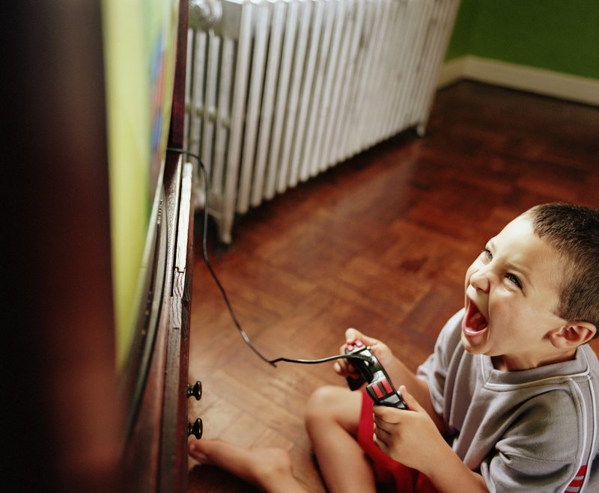
Getty Images

BY ALICE PARK
MARCH 24, 2014
Ever since Columbine, in which two students went on a deadly rampage at their high school, television, movies, and video games have been a popular target for senseless acts of violence. After the shooting, the media pushed the narrative that Eric Harris and Dylan Klebold’s inclinations for violent video games, not to mention metal music and goth subculture, were partly to blame for the horrific incident.
Nearly 15 years later, that hasn’t discouraged teens from playing video games, especially of the violent ilk. Approximately 90% of children in the U.S. play video games, and more than 90% of those games involve mature content that often includes violence. The connection between violent media and aggression has also spawned a body of research that has gone back and forth on the issue.
Worries about how violence in virtual reality might play out in real life have led legislators to propose everything from taxing violent video games to proposing age restrictions on who can buy them. The inconsistent state of the literature was enough to prompt President Obama in 2013 to call for more research into how violent video games may be influencing kids who use them. While there are studies that don’t show a strong influence between violent media and acts of violence, an ever growing body of research does actually support that violent games can make kids act more aggressively in their real-world relationships.
In the latest work to address the question, published in the journal JAMA Pediatrics, scientists led by Craig Anderson, director of the center for the study of violence at Iowa State University, found hints that violent video games may set kids up to react in more hostile and violent ways.
MORE: Children Who Hear Swear Words on TV Are More Aggressive
Working with 3,034 boys and girls in the third, fourth, seventh, and eighth grades in Singapore, Anderson and his colleagues asked the children three times over a period of two years detailed questions about their video game habits. They were also given standardized questionnaires designed to measure their aggressive behavior and attitudes toward violence.
Overall, the students’ scores on aggressive behavior, as well hostile attitudes and fantasies about violence against others, declined slightly throughout the study. That’s because children tend to act less aggressively as they get older, and learn more mature ways of dealing with conflicts than lashing out.
But a closer look at kids who played more hours of violent video games per week revealed increases in aggressive behavior and violent tendencies, compared to those who played fewer hours a week. When asked if it was okay for a boy to strike a peer if that peer said something negative about him, for example, these kids were more likely to say yes. They also scored higher on measures of hostility, answering that they would to respond with aggressive action when provoked, even accidentally. The more long-term gamers were also more likely to fantasize about hitting someone they didn’t like.
MORE: Violent Video Games Don’t Make Us Less Caring
“What this study does is show that it’s media violence exposure that is teaching children and adolescents to see the world in a more aggressive kind of way,” says Anderson. “It shows very strongly that repeated exposure to violent video games can increase aggression by increasing aggressive thinking.”
Brain imaging studies also hint that exposure to violent gaming may actually temporarily change the brain. In a 2011 study, for example, after a week of daily video gaming, brain scans of a small group of volunteers showed less activity in the regions connected to emotions, attention, and inhibition of impulses compared to participants who played non-violent video games. The effect appeared to be reversible, but the results suggested that extended periods of play could lead to more stable changes in the brain.
Previous studies have suggested that the short-term effects of spiking stress hormones–typical of the fight-or-flight response–can rev up players’ sensitivity to slights or provocations, and that playing violent games can lead to longer-term suppression of empathy. Another recent study purported to find a link between violent video games and racism. Anderson and his team, however, did not see any significant difference in empathy among the players who played more or fewer hours. That confirmed earlier lab-based studies that showed both undergraduates who played violent games and those that played non-violent ones were equally likely to help scientists pick up dropped pens.
MORE: How Playing Violent Video Games May Change the Brain
The evolving literature is why some researchers, including Christopher Ferguson, chair of the psychology department at Stetson University, insist there isn’t strong evidence that exposure to violent video games leads to more aggressive behavior. He notes, for example, that the rise in popularity of video gaming has not been matched by a similar rise in violent crime among adolescents who are most likely to play them. Studies that link violent video games to violent behavior, he says, often fail to account for other factors that can contribute to aggression, such as violence in the home, abuse, and mental illness.
Anderson acknowledges that his own study isn’t perfect, and that it’s not likely to be the last word on this controversial topic. While he used measures of aggressive behavior and violent thinking that are well-established scientific tests, these required the children to report on their own actions and attitudes, which isn’t always as reliable or as consistent as an objective measure.
The fine point of this continued debate, though, is that not all players of violent video games are destined to commit violent crimes. What studies like this highlight is the need for a more nuanced picture of the tipping point between violent games and violence, and a better understanding of how the virtual influences regulate real-life behavior.

