Exit Slip-First Day

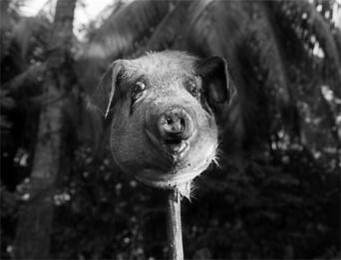
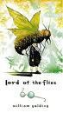
Background Information Lord of the Flies
by William Golding Published in 1954
“It was simply what seemed sensible for me to write after the war
when everyone was thanking God they weren’t Nazis. I’d seen enough to realize that every single one of us could be Nazis.”
_William Golding
What does this quote mean to you?

