ELA 10A: MOVIE REVIEW
CC A10.4 Compose and create a variety of written literary (including a historical persona essay and a review) and informational (including an observation [eye witness] report and research or technical report) texts attending to the various elements of discourse (audience, purpose, speaker, form)
Essential Questions-How do our perceptions of what is a challenge depend on our personal stories or experiences? What are some of the challenges and struggles that have shaped society? How have those challenges/struggles shaped society?

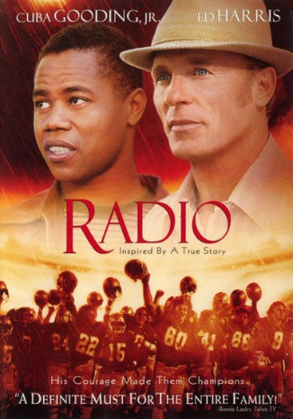

Imagine…Radio has just hit theatres. It is your job, as a movie critic that writes for the local newspaper, to convince people to go see the movie. Or, if you didn’t like the movie, to convince them that they shouldn’t go see it.
Your review must:
    - APPROXIMATELY a page long or 300 words
    - be in good copy format
    - contain the elements of a movie review (above)
    - consider and be appropriate for your audience (teenagers) and purpose (convince them to go see the movie or not to go see the movie.
    - “look” like a movie review written for a newspaper (include a photo, a caption, and be written in columns)
Evaluation: /5 Word Choice
/5 Organization
/5 Conventions
/10 movie review elements (see above)
/5 the writing suits audience, purpose, and format
/2 BONUS MARKS for handing this sheet in

MOVIE REVIEW TEMPLATE

Note: DON’T FORGET that movie titles are written within “quotation marks!”

HEADLINE: Include the title of the movie (try to use a pun!)

PARAGRAPH #1: Introduce the movie by stating that you’ve just seen this movie and would like to give an opinion about it. Mention a couple of details that might help the reader understand what type of movie you are talking about.

PARAGRAPH #2: Summarize the plot (story). Where and when did it take place? Who are the main characters? What is the story about?
Remember, do NOT include spoilers and do not tell how the story ends!

PARAGRAPH #3: Talk about the actors/actresses and discuss who did a good job and who didn’t. (You may want to include the director or writer)

PARAGRAPH #4: Talk about what you liked about the movie and what you didn’t like. Be sure to include specific details and scenes.

PARAGRAPH #5: What lessons did you learn from this story (theme/ moral)? What do you think others will learn from it? How could this movie relate to the larger idea of overcoming challenges?

PARAGRAPH #6: What group of people would like this movie? Who would you recommend it to? Who would you not recommend it to? What’s the MPAA rating of the movie (G, PG, PG-13, R, etc…)? What is your final word on the film: Is it good or bad?

RATING SYSTEM: Give the movie a score. You can do grades (A,B,C,D,F+ or -), stars (*** out of *****), numbers (3 out of 5) or something totally original… just don’t use “thumbs up” or “thumbs down.”

Use this organizer to gather the information as you view “Radio”
What type of movie do you think this is? (genre)
Where and when did it take place?
Who are the main characters?
Describe 4 characters in detail | - –  - –  - –  - –
What is the story about? Describe the plot briefly
What did you enjoy or no enjoy about this movie?
What lessons did you learn from this story (theme/ moral)? What do you think others will learn from it?

What group of people would like this movie? Who would you recommend it to? Who would you not recommend it to? What’s the MPAA rating of the movie (G, PG, PG-13, R, etc…)? What is your final word on the film: Is it good or bad?

What’s the MPAA rating of the movie (G, PG, PG-13, R, etc…)?
What is your final word on the film: Is it good or bad?
- Support your rating, providing specific details regarding the following:
  - Quality of the production (visual effects, setting, props…did it look believe able?) (2)
  - Note the cast and comment on their selection and performances (2)
  - story (summarize briefly, discuss the quality) (2)
  - the big idea of courage and challenges (as we have been thinking about in class) (2)

