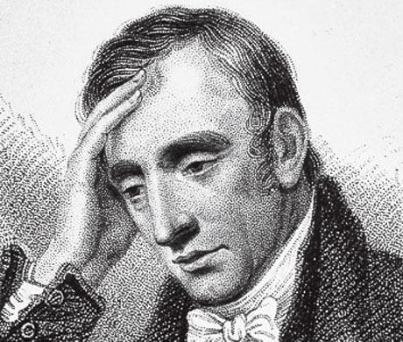
William Wordsworth
(1770-1850)

Five interesting facts:
- Revolutionized poetry from how it had been written in previous eras
- Focused primarily on nature
- Lived in the country – the ideal of the Romantics
- Wrote about common people, in simple language
- Friends/writing partner with Coleridge

My Heart Leaps Up

My heart leaps up when I behold
A rainbow in the sky:
So was it when my life began;
4 So is it now I am a man;
So be it when I shall grow old,
Or let me die!
The Child is father of the Man;
8 And I could wish my days to be
Bound each to each by natural piety. ¹ 1. Piety: reverence, affection

- What could the “rainbow in the sky” symbolize?

- Notice the repeating phrase of “So” in lines 3-5. What is the effect of the repetition? What changes do you notice?

- What does Wordsworth mean by “The Child is father of the Man”?

- What does Wordsworth hope he spends his life appreciating when he writes “wish my days to be / Bound to each by natural piety”?

- This poem is generally considered a summary of Wordsworth’s philosophy. What is it?
The World Is Too Much With Us

1 The world is too much with us; late and soon,
Getting and spending, we lay waste our powers;—
Little we see in Nature that is ours;
4 We have given our hearts away, a sordid boon!
This Sea that bares her bosom to the moon;
The winds that will be howling at all hours,
And are up-gathered now like sleeping flowers;
8 For this, for everything, we are out of tune;
It moves us not. Great God! I’d rather be
A Pagan suckled in a creed outworn;
11 So might I, standing on this pleasant lea,
Have glimpses that would make me less forlorn;
Have sight of Proteus rising from the sea;
14 Or hear old Triton blow his wreathèd horn.

Sordid - involving ignoble actions or motivations
Boon - a thing that is helpful or beneficial
Lea - grassland or pasture
Proteus - Early prophetic Greek god of rivers and oceanic bodies of water
Triton - Greek god, messenger of the sea
Wreathe - cover, encircle, surround

In what ways does this poem reflect characteristics of Romanticism?

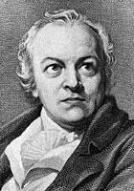
William Blake
(1757-1827)

Five interesting facts:
- He was not only a poet, but also an artist & print-maker
- Largely unappreciated while he was alive
- Contemporaries labelled him as “mad” because he was quite eccentric
- Published poems along with plates (engravings)
- Two famous books of poetry: Songs of Innocence and Songs of Experience, which include two different interpretations of the same poetic topics.

The Lamb (From Songs of Innocence)  Little Lamb, who made thee?  Dost thou know who made thee?  Gave thee life, & bid thee feed  By the stream & o'er the mead;  Gave thee clothing of delight,  Softest clothing, wooly, bright;  Gave thee such a tender voice,  Making all the vales rejoice?  Little Lamb, who made thee?  Dost thou know who made thee?  Little Lamb, I'll tell thee,  Little Lamb, I'll tell thee,  He is called by thy name,  For he calls himself a Lamb.  He is meek, & he is mild;  He became a little child.  I a child, & thou a lamb,  We are called by his name.  Little Lamb, God bless thee!  Little Lamb, God bless thee! | The Tyger (From Songs of Experience)  Tyger! Tyger! burning bright,  In the forests of the night,  What immortal hand or eye  Could frame thy fearful symmetry?  In what distant deeps or skies  Burnt the fire of thine eyes?  On what wings dare he aspire?  What the hand dare sieze the fire?  And what shoulder, & what art,  Could twist the sinews of thy heart?  And when thy heart began to beat,  What dread hand? & what dread feet?  What the hammer? what the chain?  In what furnace was thy brain?  What the anvil? what dread grasp  Dare its deadly terrors clasp?  When the stars threw down their spears,  And water'd heaven with their tears,  Did he smile his work to see?  Did he who made the Lamb make thee?  Tyger! Tyger! burning bright  In the forests of the night,  What immortal hand or eye  Dare frame thy fearful symmetry?
William Blake's "The Lamb"
Stanza One:
- Who is the speaker addressing?
- The poem opens with a question. What is it? What kind of question is it?
- What is the rhyme scheme of the poem?
- What are the points the speaker mentioned as given to the Lamb by his Creator?
Stanza Two:
- The second stanza is an answer to the question. Who answers the question?
- What is the significance of capitalization in the fourth line?
- Who is meek, mild and child? Who is the speaker describing here?
- What is the relation between "I a child" and "Songs of Innocence"? How old could the speaker be?
- How is the speaker comparing himself to the lamb? And what are they both compared to?
- What is the central symbol of the poem?
- What are the connotations of softest, bright, tender, meek, and mild? What do these words imply about the creator?
- What feeling about the creator does this poem suggest?
William Blake's "The Tyger"
Stanza One:
- Who is the speaker addressing?
- What is the question of this stanza?
- What is the rhyme scheme of the stanza?
- How does this poem start in a similar style as "The Lamb"?

Stanza Two:
- What are the questions in this stanza?
- What does he mean by "deep" and "skies"?
- What does the "he" in the third line refers to? Why is it not capitalized like "He" in "The Lamb"?
- What is the effect of the repeating “d” sound throughout the stanza? The repetition of the word “dare”?
- What is the meaning of the last question?
Stanza Three:
- How is the tiger's heart described?
- What is the significance of the word "dread"?
Stanza Four:
- What tools are used by the Creator? What does that compare Him to?
- Whose greatness is glorified here, the tiger's or the creator's?
Stanza Five:
- This stanza poses the central question of this poem? What is it?
Stanza Six:
- This stanza is a repetition of the first stanza with ONE word changed? What is it? What is the effect?

Holy Thursday (From Songs of Innocence)

'Twas on a holy Thursday, their innocent faces clean,
The children walking two and two in red and blue and green,
Grey-headed beadles walked before, with wands as white as snow,
Till into the high dome of Paul's they like Thames waters flow.
O what a multitude they seemed, these flowers of London town!
Seated in companies they sit, with radiance all their own.
The hum of multitudes was there, but multitudes of lambs,
Thousands of little boys and girls raising their innocent hands.
Now like a mighty wind they raise to heaven the voice of song,
Or like harmonious thunderings the seats of heaven among:
Beneath them sit the aged men, wise guardians of the poor.
Then cherish pity, lest you drive an angel from your door.

Holy Thursday (From Songs of Experience)

Is this a holy thing to see
In a rich and fruitful land, -
Babes reduced to misery,
Fed with cold and usurous hand?

Is that trembling cry a song?
Can it be a song of joy?
And so many children poor?
It is a land of poverty!

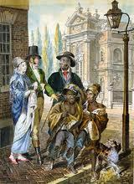
And their sun does never shine,
And their fields are bleak and bare,
And their ways are filled with thorns,
It is eternal winter there.

For where'er the sun does shine,
And where'er the rain does fall,
Babe can never hunger there,
Nor poverty the mind appal.

“Holy Thursday” Poems

- (a) How is the feeling of a children’s poem created using:
- Rhythm?
- Rhyme?
- Imagery?

- How are these components different in the second “Holy Thursday”?

- Who are the “Grey headed beadles”? (You may need to do a quick Google search.)

- What is meant by a “usurous hand” in line 4 of the second poem? What does this suggest about the charity given to the children?

- How do these two poems differ in tone?

- What message is Blake suggesting about the treatment of children during the Romantic period in each of these two poems?

