Pre-Reading Inquiry
Indian Horse-adapted from J. Moser

Before beginning to read your novel consider some of the social, cultural, and political landscapes that define the work you will be reading.

Each of the novels studied feature vivid snapshots into distinct moments in history and into the cultural, social, and psychological landscapes that define the characters and their relationships to one another.
_______________________________________________________________

Richard Wagamese’s Indian Horse is set in Ontario, Canada in the late 1960s. Through the characterization of two young sisters who are removed from their family, Wagamese illustrates the difficulties that many First Nations and Métis people have faced—these difficulties are compounded by poverty, societies’ negative perceptions, and some of the discriminatory narratives that underscored Canadian policy.
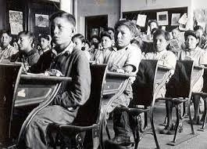

Your task is to do some research on the effects of Residential Schools and the sixties scoop, responding to the following questions:
- What were some of the policies that facilitated the implementation of programs like the residential schools and the sixties scoop?
- What effects did these racial policies have on the First Nations and Métis cultures?
- Are there any contemporary issues that can be connected to the loss of cultural identity?
- Find one primary document (newspapers, government documents, first hand experiences) that would be relevant to the loss of cultural identity of Aboriginal people as a result of the sixties scoop. Print a copy of this document and provide a brief explanation as to how the document relates to loss of cultural identity

Using your research write a 2 to 3 paragraph response (use some creativity be descriptive) to the questions and print two copies. One copy should be kept by you, as you will use the information during your first literature circle meeting, and the second copy will be handed in for marks.

